CLASSROOM PEER REVIEW PORTAL
@CREATIVITY THINK (9483175986/7019689991)

ABSTRACT:
The Classroom Peer Review Portal is a web-based academic evaluation system designed to streamline peer assessment of assignments in schools, colleges, and online learning platforms. The system enables students to upload assignments, participate in anonymous peer reviews, and receive aggregated feedback and scores. Teachers can configure rubric templates, manage review workflows, flag unfair evaluations, and monitor progress through a comprehensive dashboard. Built using Django REST Framework and React, this platform ensures structured, unbiased, and scalable peer review operations that improve learning outcomes, critical thinking, and collaborative evaluation..

INTRODUCTION OF THE PROJECT:
Assessment is a crucial part of education, yet traditional teacher-only grading often limits personalized feedback and increases workload. Peer review offers students the opportunity to learn from others’ work while practicing critical evaluation.
The Classroom Peer Review Portal digitizes the entire process—allowing assignments to be uploaded, reviewed anonymously, and scored based on predefined rubrics. Teachers can monitor review cycles, detect anomalies, adjust final scores, and generate grade sheets. The system’s analytics dashboard offers insights into class performance, rubric-wise scoring, and student review participation..

PROJECT OBJECTIVES:

• Enable students to upload assignments in various formats
• Support anonymous peer review allocation
• Provide customizable rubric templates for consistent scoring
• Aggregate peer scores and generate final evaluation
• Provide feedback and review history for each student
• Enable teachers to monitor review progress in real-time
• Detect and flag unfair or biased reviews
• Offer analytics per class, assignment, rubric category, and student
• Provide exportable grade sheets for record keeping
• Improve learning through structured peer feedback

PROBLEM OF THE STATEMENT:
Manual peer review processes lack anonymity, consistency, and structured scoring, often leading to bias and inefficiency. Teachers struggle to track who reviewed whom, ensure fairness, and compile final grades.
This project addresses these challenges by offering an automated peer allocation system, rubric-based evaluations, real-time monitoring, and analytics that ensure transparent and unbiased peer assessment..

MOTIVATION OF THE PROJECT:
• To reduce teacher workload through automated peer evaluation
• To promote collaborative learning and critical thinking
• To ensure unbiased reviews via anonymity and rubrics
• To provide meaningful, structured feedback to students
• To digitize and track review workflows accurately
• To help educators access analytics and insights for academic improvement
• To create a scalable system suitable for both classrooms and online courses

BLOCK DAIGRAM OF PROJECT:

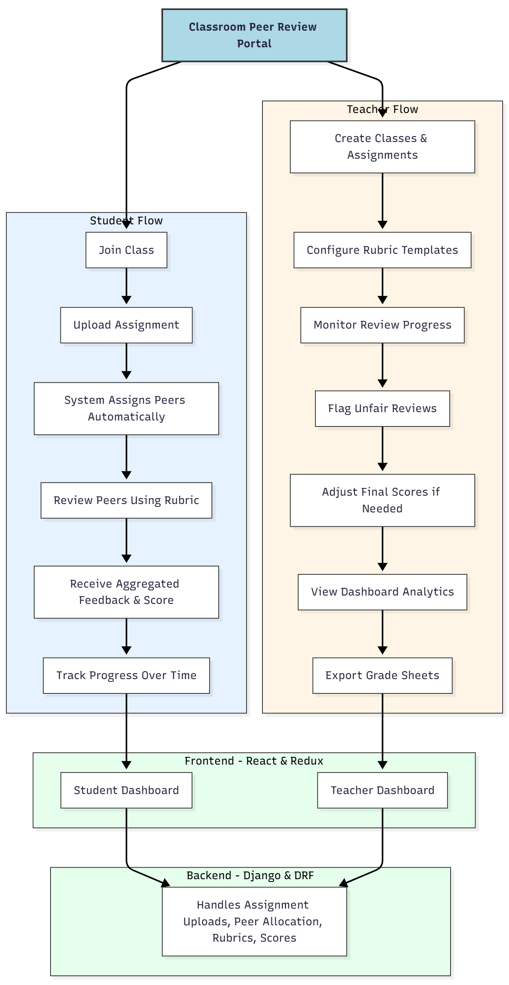

WORKING OF THE PROJECT:
Students log into the portal and join their respective class using a code. They upload their assignments, after which the system automatically assigns a set number of peers for anonymous review. Students review each assigned submission using teacher-configured rubrics.
Teachers track review progress, identifying missing or unfair reviews through abnormal scoring patterns. After the review cycle ends, the system aggregates scores and generates final evaluations. Teachers can adjust grades if needed and download grade sheets.
The dashboards give insights into class performance, distribution of scores, and student engagement across assignments..

SOFTWARE REQUIREMENT:
- Backend:
  - Python 3.x
  - Django
  - Django REST Framework
  - SQLite/PostgreSQL
- Frontend:
  - Node.js and npm
  - React.js
  - Axios
- Development Tools:
  - Visual Studio Code
  - Postman (for testing APIs)
  - Git/GitHub (for version control)
- Server/Deployment (Optional):
  - Gunicorn, Nginx, or Heroku/AWS for hosting

ADVANTAGES OF THE PROJECT:

• Ensures anonymous and unbiased peer evaluation
• Reduces teacher workload significantly
• Provides meaningful feedback to students
• Customizable rubric templates ensure consistent scoring
• Automated peer assignment eliminates manual effort
• Detects unfair reviews using analytics
• Exportable grade sheets simplify academic record keeping
• Boosts student critical thinking and evaluation skills

APPLICATIONS OF THE PROJECT:
• Schools and high schools
• Colleges and universities
• Online learning platforms
• Skill development courses
• Project-based learning environments

REFERENCES:

- Django REST Framework Documentation — Django Software Foundation. Django Documentation. Available: https://docs.djangoproject.com/
- Django REST Framework. DRF Documentation. Available: https://www.django-rest-framework.org/
- React. React Official Documentation. Available: https://reactjs.org/docs/getting-started.html
- Redux. Redux Documentation. Available: https://redux.js.org/introduction/getting-started
- PostgreSQL Global Development Group. PostgreSQL Documentation. Available: https://www.postgresql.org/docs/
- MySQL. MySQL Reference Manual. Available: https://dev.mysql.com/doc/
- Git. Git Documentation. Available: https://git-scm.com/doc
- Node.js. Node.js Documentation. Available: https://nodejs.org/en/docs/
- Axios. Axios Documentation. Available: https://axios-http.com/docs/intro
- Socket.io Documentation – https://socket.io/docs/

